O.a-n - Oceans | O1-5 |

O.Q Exam questions from past papers
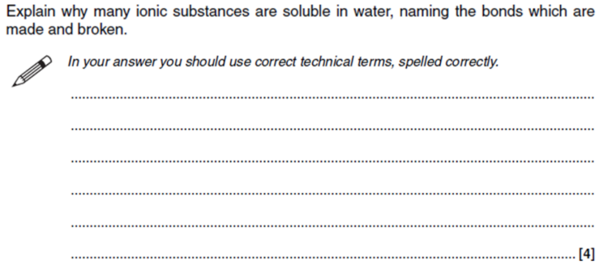  Explain why many ionic substances are soluble in water,naming the bonds which are made and broken (4) | 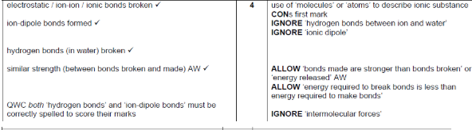  - Ionic bonds and hydrogen bonds are broken (2)  - Ion-dipole bonds formed (1)  - Bonds made are stronger than bonds broken -> exothermic reaction (1)  Mark Schemes do not allow ionic dipole
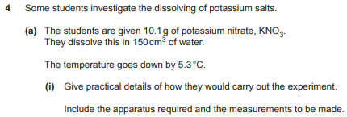  Describe the practical details of how a student would carry out to find the enthalpy change of solution of KNO₃(s) from having 150cm³ of water and 10.1g of KNO₃(s) (4) | - Measure water using measuring cylinder (1)  - Use a polystyrene cup (1)  - Measure initial temperature (1)  - Then add solid and measure final temp when temperature change becomes constant (1)  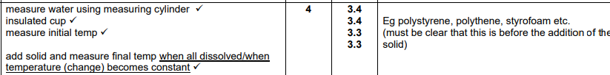
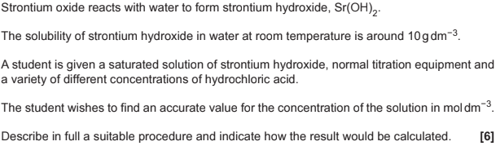  Describe in full a suitable procedure and indicate how the result would be calculated? | 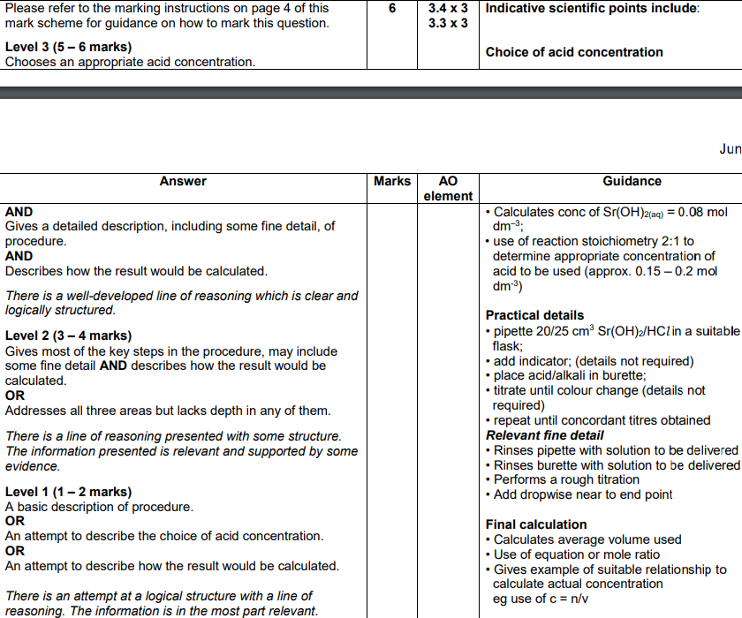  Choice of acid concentration  - Calculates conc of Sr(OH)_{2(aq)} = 0.08  - Use of reaction mole ratio 2:1 to approximate concentration of acid used (approx 0.15 - 0.2 mol dm⁻³)  Practical details  - Pipette 20/25cm³ Sr(OH)₂ in a suitable flask  - Add indicator; (details not required)  - Place acid in burette  - Titrate until colour change (details not required)  - Repeat until concordant titres obtained  Relevant fine detail  - Rinses pipette and burette with solution to be delivered  - Performs a rough titration  - Add dropwise near to end point  Final calculation  - Calculates average volume used from concordant titres  - Use of equation of mole ratio  - Gives example of suitable relationship to calculate actual concentration eg use of c=n/v
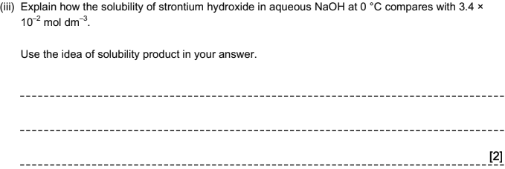  Explain how the solubility of Sr(OH)₂ in aqueous NaOH at 0 degrees compares with 3.4x10⁻² moldm⁻³ [Compared to dissolving in water]  Ksp = [Na⁺][OH⁻] | 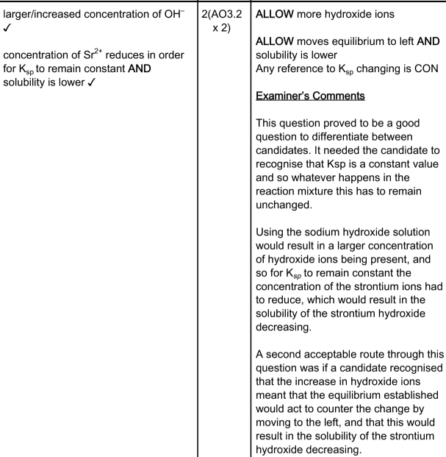  - Larger concentration of OH-  - Concentration of Sr²⁺ reduces in order for K_{sp} to remain constant and solubility is lower
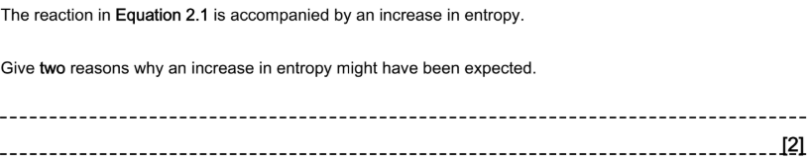  Give two reasons why an increase in entropy might have been expected? | 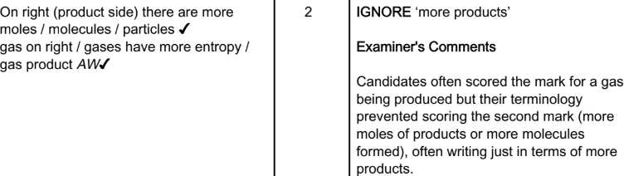  - On right side there are more particles  - A gas is on the right side which has more entropy than liquids
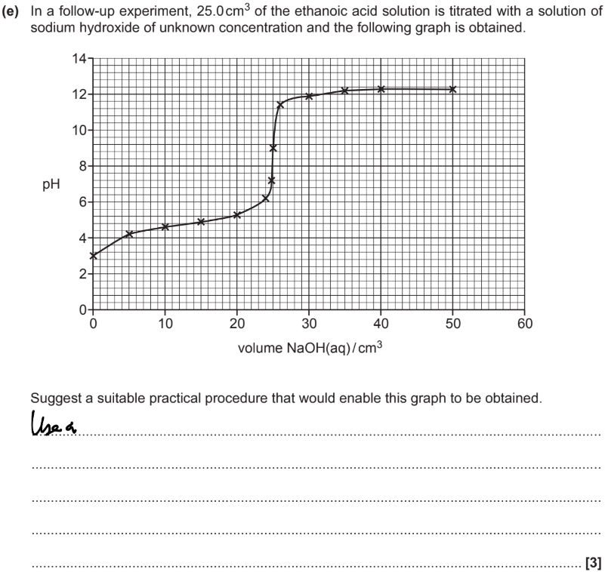  Suggest a suitable procedure that would enable this graph to be obtained? | - Put NaOH in burette  - Pipette 25cm³ of ethanoic acid into conical flask  - Measure pH with pH meter  - Run NaOH at 5cm³ volumes at a time  - Run at 1cm³ volumes when pH starts to change rapidly  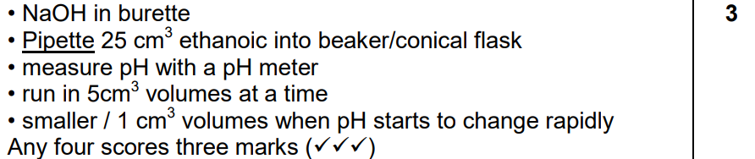

O.a-h - Energetics | O1 | O4 | O5 |
What is a solute? | Something being dissolved into a solvent
What is a solvent? | The liquid in which a solute is dissolved in to form a solution
When does a solution USUALLY dissolve and not dissolve? | - Dissolves when a reaction is exothermic where more energy is released when bonds are made  - Doesn’t dissolve when a reaction is endothermic where more energy is required to break the bonds  Usually as its different if entropy applies
When does an ionic substance generally dissolve? | If the hydration enthalpy > lattice enthalpy so the overall enthalpy change is negative  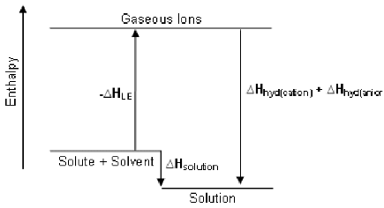  See above, the ‘aqueous ions’ will be lower than the ‘ionic lattice’.
Draw the diagram for a hydrated potassium ion & a hydrated bromide ion? | 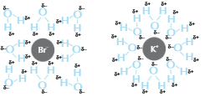  - You can draw 1 molecule of water then 2 or more arrows like this  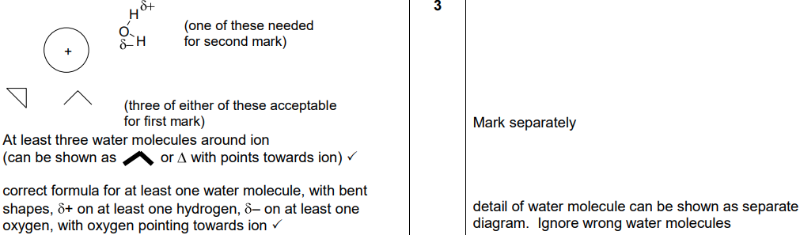  Draw at least 3 water molecules and label partial charges, if a question mentions the name of the cation or anion make sure to put it not just a + or -
Define enthalpy change of solution (∆_{sol}H)? | The enthalpy change when 1 mole of an ionic lattice dissolves in enough solvent to form an infinitely dilute solution  E.g. NaCl_{(s)} -> Na⁺_{(aq)} + Cl⁻_{(aq)}
Define lattice enthalpy (∆_{LE}H)? | The enthalpy change when 1 mole of an ionic lattice is formed from its gaseous ions  E.g. Na⁺_{(g)} + Cl⁻_{(g)} -> NaCl_{(s)}  We want the energy needed to break the lattice and so we take the negative of the Lattice enthalpy
Define enthalpy change of hydration of ions (∆_{hyd}H), ? | The enthalpy change when 1 mole of aqueous ions is formed from its gaseous ions  E.g Na⁺_{(g)} + 2Cl⁻_{(g)} -> Na⁺_{(aq)} + 2Cl⁻_{(aq)} [∆_{hyd}H(Na⁺) + 2 x ∆_{hyd}H(Cl⁻)]  If you had 2 moles then times the ∆_{hyd}H of that cation/anion by 2
What can lattice enthalpy be used as a measure of? | Ionic bond strength
What 2 factors affect lattice enthalpy and enthalpy change of hydration? | - Charge difference between ions:  Greater charge difference-> attract water molecules more -> stronger ion dipoles -> more energy released -> more exothermic lattice enthalpy  - Ionic radius:  Smaller ionic radius -> attract water molecules more -> stronger ion dipoles -> more energy released -> more exothermic lattice enthalpy
Why would LiF be more exothermic (more negative ∆_{LE}H ) than NaF | - Li compared to Na have the same charge  - Li ionic radius is smaller than Na and so would have a greater charge density -> would attract the F more
Why would MgO be more exothermic (more negative ∆_{LE}H ) than Na₂O? | - Mg compared to Na have a similar size ionic radius  - Mg ion has a 2+ charge compared to Na + charge and so would have a greater charge density -> would attract the O more
What does enthalpy change of solution tell you about solubility and why? | The more negative/exothermic the more soluble a substance is -> bond making is exothermic and bonds are made when water molecules bond to ions
How is enthalpy of hydration and lattice enthalpy related to enthalpy of solution? | 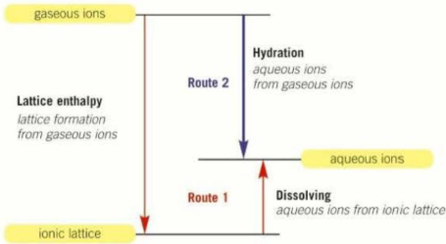  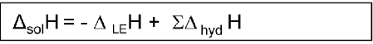  For hydration enthalpies it's the sum of the hydration of the cation and anion
Define Entropy (S)? | A measure of disorder of a chemical system and the number of ways of arranging the particles and their energy
How is the entropy change of a system (ΔS_{sys}) calculated? What is it measured in? And what does it being +ve and -ve mean? | - ΔS_{sys} = ∑S_{products} - ∑S_{reactants}  - Measured in Jk⁻¹mol⁻¹  - +ve means increase in disorder/entropy  - -ve means decrease in disorder/entropy  S alone is the entropy per molecule which is always positive
What is the trend in order of magnitude for the ΔS_{sys} for a solid, liquid or gas and why? | - Gas > liquid > solid as gas particles has more arrangements and configurations than a liquid  - Gas particles have more energy than liquid particles and so would have more arrangements in filling up energy levels in terms of translational,rotational,vibrational or electronic levels  What is applied to comparing gas and liquids can be used to compare liquids and solids.  Think of the analogy of giving people £1 compared to £5 to shop at Rio’s, when people spend the money there is a higher chance the people with £1 would have the same money left compared to £5 as there are more spending configurations with £5 than £1 if you switch money with energy then you see - Mrs Marsden
How is entropy change of surroundings (ΔS_{surr}) calculated? | - ΔS_{surr} = -ΔH/T  - Measured in Jk⁻¹mol⁻¹  Where T is in K. There is a negative sign as ΔH represents the system and since what you do to the surroundings will be opposite to the system there would be a - sign
How is total entropy change (ΔS_{tot}) calculated? And what does it being +ve and -ve mean? | - ΔS_{tot} = ΔS_{sys} + ΔS_{surr}  - +ve means the process is spontaneous  - -ve means the process isn’t spontaneous  - Measured in Jk⁻¹mol⁻¹  Spontaneous means reactions that go of their own accord
What is the significance of a reaction equilibrium mixture where ΔS_{tot} = 0 | - The reaction is feasible  - The reaction is at equilibrium (therefore forward and backward reactions occur at the same rate)  - K_{c} = 1  Feasible means reactions which are energetically favourable, a reaction that should go
Define solubility product K_{sp}? | - Is when a sparingly soluble solid is dissolved in water to produce a saturated solution  - E.g Ba(OH)₂ (s) ⇌ Ba²⁺ (aq) + 2OH⁻ (aq) and therefore K_{sp} = [Ba²⁺_{aq}][OH⁻_{aq}]²  The maximum amount of solid which will dissolve in a certain solvent at a SPECIFIC TEMPERATURE
What should you be aware of when tackling K_{sp} questions? | - K_{sp} only changes with temperature and the [aq products] has to change to make it constant  - Putting state symbols in K_{sp} equation  - Comparing for e.g NaOH_{(s)} and Be(OH)₂(s) where in NaOH(s) ⇌ Na⁺ + OH⁻ and Be(OH)₂ ⇌ Be²⁺ + 2OH⁻ so twice as many moles for OH⁻  - Comparing for e.g NaOH(s) and Be(OH)₂(s) where in K_{sp} for NaOH is [OH] whilst in Be(OH)₂ is [OH]²

O.i-m - Equilibria (acid-base) | O2 | O3 |
What is a Brønsted–Lowry acid/base? (use equations for strong acids/bases? | - A substance that DONATES or ACCEPTS a proton  - Base (B): B + H₂O -> BH⁺ + OH⁻  - Acid (A): H₂O + HA -> H₃O⁺ + A⁻  - Acid also: HA -> H⁺ + A⁻  The H₃O⁺ is called the oxonium ion/hydronium ion but it is usually ignored
How do you find acid-base conjugate pairs? | - Look forwards and backwards for substances that differ by H⁺.  - And for substances that are the proton donors/proton acceptors  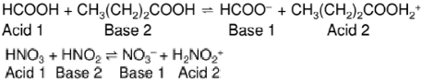  The substances will a bigger K_{a} will act as an acid.
Define Conjugate acid and conjugate base? | - Conjugate acid: Is a substance that can donate a proton to become a base (It was a base but accepted a proton to become a conj acid )  - Conjugate base: Is a substance that can accept proton to become an acid (It was an acid but donated a proton to become conj base)  E.g. HA ⇌ H⁺ + A⁻ If HA is the acid, A⁻ is the conj base and also HA is the conj acid of A⁻ and therefore A⁻ is the base in this case HA and A⁻ are the conjugate pairs
Define strong acid? | A compound that fully dissociates in an acid to produce hydrogen ions [Is regarded as a proton donor]
What is the DEFINITION of pH/The equation for pH and pK_{a} of a strong acid? | 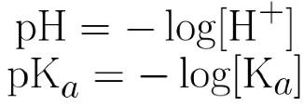  Using pKa allows for an easier comparison  When calculating H⁺/K_{a} from pH/pK_{a} make sure to do 10^{-pH}/10^{-pka} not -10^{pH}/-10^{pKa}
Define strong base | A compound that fully dissociates when reacting with an acid to produce hydroxide ions  [Is regarded as a proton donor]
What is the equation for the ionic product of water and when is it true? | 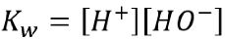  The following equilibrium is true for all (aq) substances and pure water: H₂O (I)  Since the [H₂O] excess >> [H⁺], we can treat it as constant to form a new constant
What assumptions are there for strong bases when calculating pH | All OH⁻ are from the base  The OH- from the dissociation of water is so low that its negligible
How can the ionic product of water be used? K_{w} = 1.00x10⁻¹⁴ mol⁻² dm⁻⁶ @ RTP | - To work out the pH of water since, for pure water, [H⁺] = [OH⁻]  - To convert between the [H⁺] or [OH⁻] for a dissolved substance.  Good for working out the [H⁺] ions in strong bases/alkalis
What MUST BE true for any neutral solution? | [H+] = [OH-]  Since temp changes the value of K_{w} -> [H⁺] and [OH⁻] must change -> [H⁺] is no longer 10⁻⁷ -> pH no longer 7 -> pH of a neutral solution @ any temp. Not equal to 7. Ultimately, the pH scale changes with temp
Define weak acid? | A compound that partially dissociates in water to produce hydrogen ions
What is the equation for weak acids? What assumptions are made in doing so? | Weak acids form an equilibrium mixture: HA ⇌ H⁺ + A⁻.  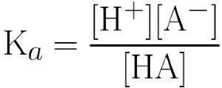  - We can assume [H⁺] = [A⁻] so all the H⁺ ions come from the dissociation of the acid and not the water  - The dissociation is so small that [HA]_{initial} = [HA]_{eqm} (this doesn’t work for ‘stronger’ weak acids).  The first assumption doesn’t work for buffers whilst the second doesn’t work for ‘stronger’ weak acids.  K_{a} is known as the acidity constant or acid dissociation constant
How does the pH and pKa of strong acids compare with weak? | The pH and pK_{a} values for strong acids are lower as they fully dissociate (ie, [H⁺]_{final} = [HA]_{initial})
How would you calibrate a pH probe from textbook? | - Wash the electrode with distilled water and then transfer the electrode into a buffer solution of pH = 7.00  - To measure the pH of acidic solutions, calibrate the electrode using an acidic buffer solution typically with a pH = 4.00  - To measure alkaline solutions calibrate the electrode using an alkaline buffer solution with pH = 10.00  - Once calibrated you can measure the pH of any solution by rinsing the electrode then putting it in the solution to be measured
Define buffer and what does it do? | A substance that Resists changes in pH when SMALL quantities of acid or base are added
What are the assumptions when weak acids act as buffers? | - [A⁻] = [Salt] the concentration of the ion from the acid is the same as the salt  - [HA]_{eq} = [HA]_{initial} the equilibrium and initial concentration of acids are the same  - A buffer doesn’t stop pH from changing it only resists it so pH changes then is resisted
Describe the way of making acid buffers using an example? | - React a weak acid with its salt (salt would be conjugate base): E.g Ethanoic acid and sodium ethanoate  - The Ethanoic acid is a weak acid so CH₃COOH ⇌ CH₃COO⁻ + H⁺  - The salt fully dissolves and so CH₃COO⁻Na⁺ -> CH₃COO⁻ + Na⁺  - Combining the two forms CH₃COOH ⇌ CH₃COO- + H⁺ of which there is a lot of weak acid (ethanoic acid molecules) and ions (ethanoate ions from salt)
How should you tackle a buffer question? (not a calculation qu) | - Write down the definition of a buffer if it is not mentioned in the question  - Write down the equation if not shown:  - Eg, HCOOH (high conc) ⇌ HCOO⁻ (low) + H⁺ (low)  3. State what happens when acid is added:  - H+ ions reacts with HCOO⁻ POE shifts to the left to make more HCOOH (by Le Chatliers).  4. State what happens when base is added:  - OH⁻ ions reacts with H⁺ forms H₂O so POE shifts to the right to replace H⁺ ions  5. State that pH remains constant as concentration of [HCOOH] and [HCOO⁻] are both large
What is the expression for K_{a} for weak acids as BUFFERS and what does it mean? | - $K_{a}=[H^{+}]× \frac{[A^{-}]}{[HA]}$  - [A-]/[HA] is a ratio so you don’t always need the concentration for both substances also the ratio of concentrations for both does change even if the volume of salt differs for the same solution  - Altering [A-] or [HA] will affect how well a substance will buffer an acidic solution  Ratio [A-]/[HA] is usually between ¼ or 4/1 to buffer as any larger quantity would be more than a ‘smaller quantity’ so it wouldn’t resist the change in pH

O.n - Energy & Matter | O2 |
What is the effect on bonds when they absorb infrared radiation? | Bonds vibrate more
What is the main type of radiation that reaches the Earth from the sun (solar energy)? And how much does the earth absorb from it and what occurs after? | - UV and Visible light  - Some of this energy is absorbed which heats up the earth  - The Earth radiates IR radiation
Name 3 greenhouse gases and what are their effects in the troposphere | - Water vapour, methane and CO2  - They absorb some of the IR in the IR window  Not in the stratosphere haha and oxygen and ozone isn’t a greenhouse gas
What is the IR window? | The wavelength of infrared radiation that water vapour does not absorb in the troposphere  As water vapour is the most abundant greenhouse gas so the wavelengths it absorbs is the most important
What happens when greenhouse gas molecules absorb extra IR radiation in the troposphere? | The molecule's bond increases in vibrational energy to which the molecule transfers energy via colliding with other molecules which would increase their KE and raise the temperature  Not in the stratosphere hahaha
What occurs with some absorbed IR by the greenhouse gas molecules in the troposphere? | - They re-emitted some of the absorbed IR in all directions some of which heats up the earth  It doesn’t transmit or reflect it re-emits it and again not in the stratosphere hahahaha
What occurs when the concentration of greenhouse gases increases? | This leads to an enhanced greenhouse effect

